Chapter 16, Problem 31.

Obtain v(t) and i(t) for t > 0 in the circuit in Fig. 16.54.

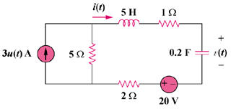

Figure 16.54
For Prob. 16.31.

